Getting started with Grove Sensors

Scratch Version

February 9, 2017

# Setting up

Power up your Raspberry Pi/GrovePi, but don’t plug any sensors into it yet. You should see a screen that looks like this:



Double click on the Scratch cat:

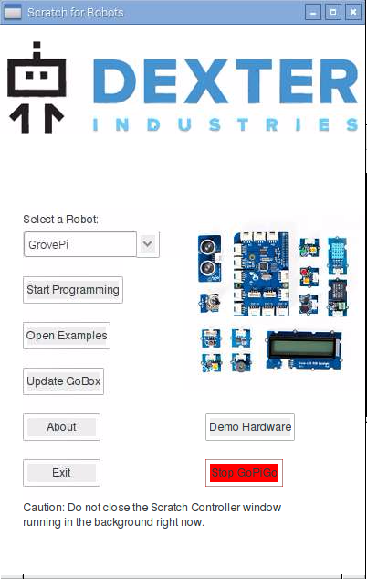

Press “Start Programming” next

Make sure that GrovePi is selected

This will pop up next. Just click “OK”.

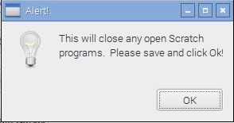

Shortly after this, you’ll see the following screen. Sometimes it says “Remote sensor connections enabled”, but not always. If it does, click through this dialog.

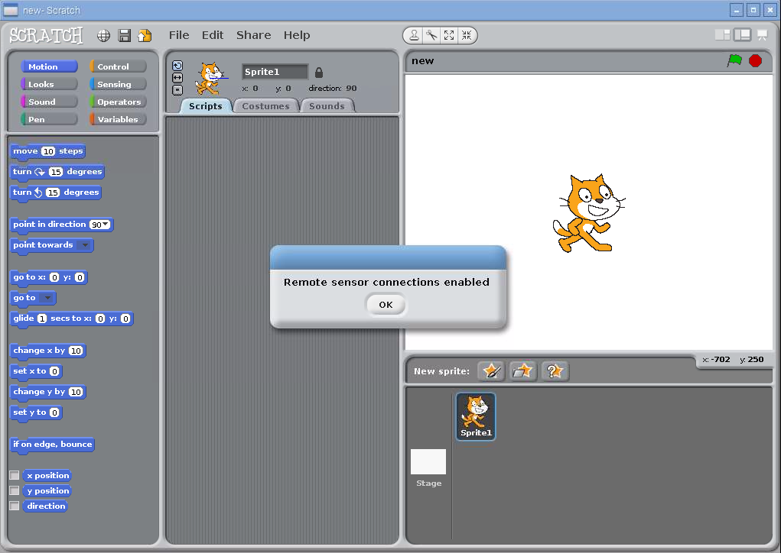

# Turning on an LED

Ok, now we can finally start programming. Find a Grove LED and cable. The Grove LED looks like this:

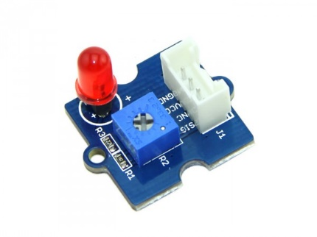

The LED may need to be plugged in. It will only work if you plug it in the right direction, but don’t worry about that now. Just plug it in and we’ll worry about whether it was plugged in the right way later.

Now find a Grove cable:

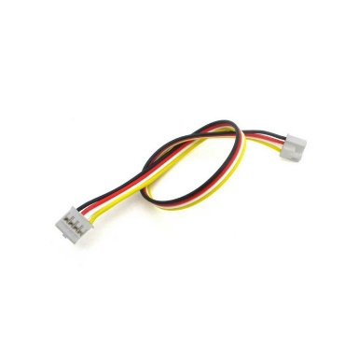

Plug one end into the LED board and the other end into the D2 connector on the GrovePi board. The D stands for “digital” which means that it can programmed to either be on or off. LEDs can either be on or off so this makes sense. You’ll notice that there are I2C, Serial, and A connectors. These are for other types of devices.

**When unplugging Grove sensors be sure to pull them by the plastic connector and not the wires. Pulling by the wires may break the cable!**

Now, go back to Scratch. You should have a blank workspace:

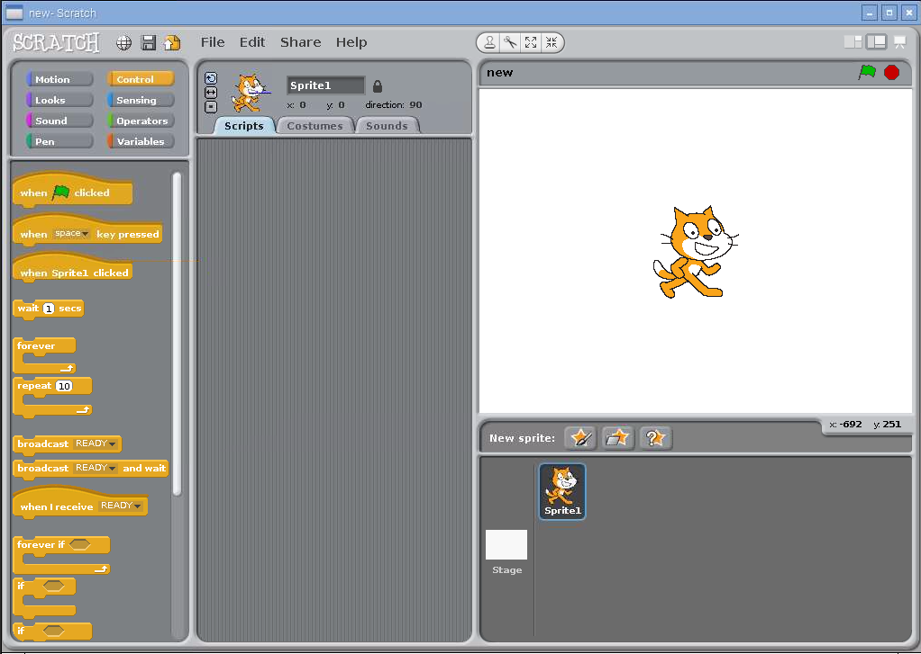

Scratch programs can turn LEDs on and off by broadcasting magic words. Try it out by placing a “broadcast” block:

Screen Clipping

Click on the black triangle to change the message and type in “led2on”:

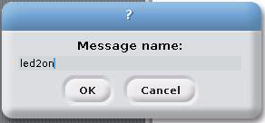

Place another “broadcast” block down and change its message to “led2off”. Your program should look like this:

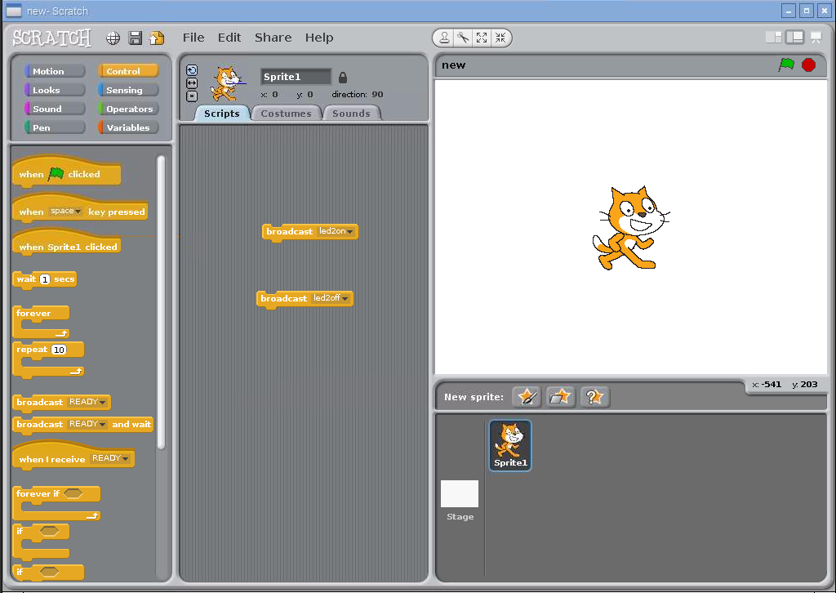

Now it’s time to test if the messages work. Double click on the “broadcast led2on” block. Did the LED light up? If it didn’t, the LED might be plugged in backwards. Gently remove the LED and plug it in the other way.

Now try double clicking the “broadcast led2off” block. Did it work?

# Going farther

Now that you know how to turn on and off an LED, here are some ideas:

1. Write a game the uses the LED
2. Make the LED blink
3. Add more LEDs and animate them
4. Write a program that asks the user which LED they want on and then turn it on for them

# Hints for other sensors

The following picture shows some of the Scratch commands for hooking up other GrovePi devices:

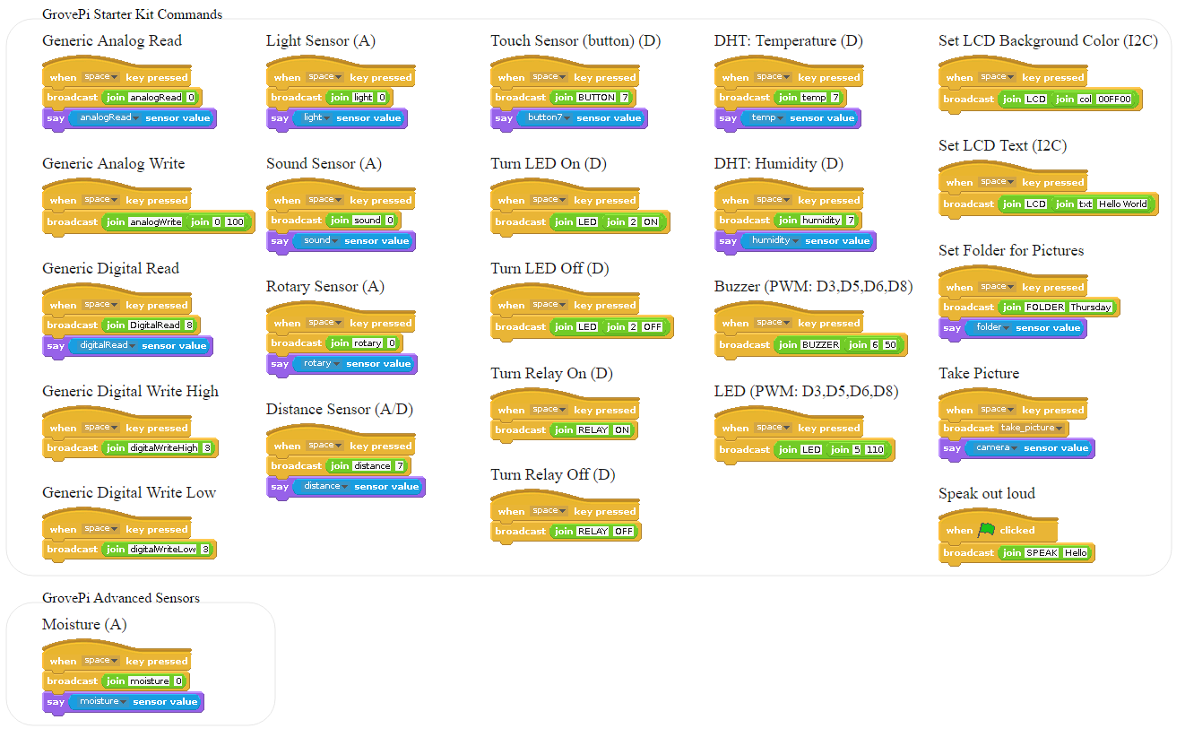

This picture can be found at <https://github.com/DexterInd/GrovePi/tree/master/Software/Scratch>.

# Examples

The Raspberry Pi has lots of example projects built into it. To explore these, go to File and Open Project: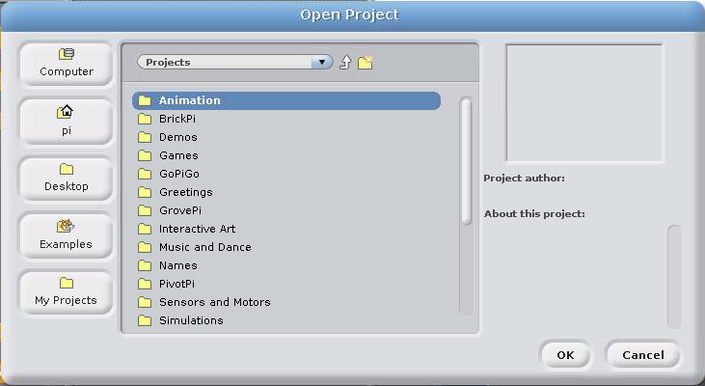

Click on Examples

The “GrovePi” directory has many programs to try.